

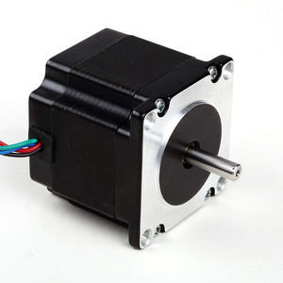

#### 57mm Hybrid Stepper Series

**SPECIFICATIONS:**

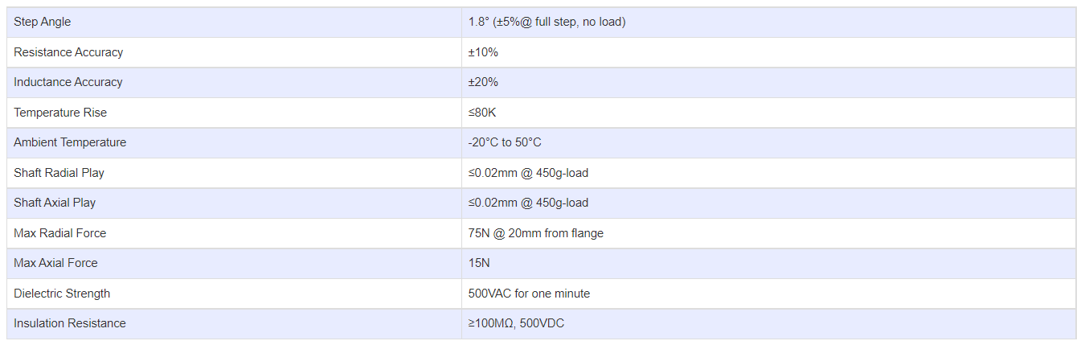

**SUBMODELS:**

*The following are common submodels for the LDO-57STH series.*

